

# Samsung Galaxy Tab A7

## Type of device: Tablet

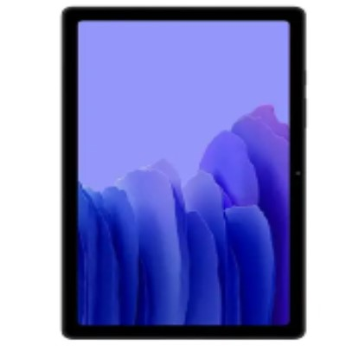

Actual Display Size : 10.4 inches

Operating System : Google Android

Network Capability : 3G,4G

Year of Release : 2020

Average Price : $560 as of 15 09 2021

Internet Access : Wi-Fi and Mobile Broadband

## Accessibility Features:

### Cognitive

* Additional Instructions
* Copy and Paste
* Flicker Free Display
* GPS
* Photo Telephone List
* Screen Timeout Disabled
* Simple Instructions
* Simple Reminders
* Simplify Display

Voice Notes

### Hearing Impairment and Deaf

* Allows for sign language communication
* Bluetooth or Wi-Fi
* Closed Captioning
* Front Facing Camera
* Hearing Aid Microphone Coupling
* Hearing Aid Telecoil Coupling
* Video Communications - Two-way

Visual Alerts - Incoming Calls

### Vision

* Accessibility APIs supported
* Battery Alert - Audible
* Bluetooth or Wi-Fi
* Braille Display Support
* Brightness Adjustable
* Dictation / Speech-to-Text
* High Contrast Mode
* Personalised Shortcuts
* Power Cue
* Screen Magnifier
* Screen Reader
* Text Size Adjustable
* Text Style Adjustable
* Voice Control /Personal Assistant

Voiced Menus

### Speech

* Allows for sign language communication
* Bluetooth or Wi-Fi
* Messaging Options - Email
* Messaging Options - IM
* Messaging Options - MMS

Predictive Text

### Physical

* Bluetooth or Wi-Fi
* Dictation / Speech-to-Text
* Gesture Based Navigation
* Headset - plug connected
* Predictive Text
* Reduced hand movement option
* Speaker-phone option
* Stylus or Prosthetic Device support
* Switch control option
* Visible Focus Indicators
* Voice Control / Personal Assistant
* Voice Recognition for Accessing Features

Voice Recognition for Dialling

## How and where to get it from?

You can buy this tablet from [Kogan](https://www.kogan.com/au/shop/category/smartphones/?q=Samsung+Galaxy+Tab+A7&page=1), [Dicksmith](https://www.dicksmith.com.au/da/shop/category/smartphones/?q=Samsung+Galaxy+Tab+A7&page=1), [Bing Lee](https://www.binglee.com.au/search?q=SM-T500NZAAXSA&page=1&limit=36&sort=relevance&mode=grid&type=products), [JB HI-FI](https://www.jbhifi.com.au/search?query=Samsung%20Galaxy%20Tab%20A7&page=1&refinementList%5Bfacets.Category%5D%5B0%5D=Android%20tablets&refinementList%5Bfacets.Brand%5D%5B0%5D=SAMSUNG), and other retailers.

## More information is available on:

[Samsung Galaxy Tab A7 Web Page](https://www.samsung.com/au/tablets/galaxy-tab-a/galaxy-tab-a7-10-4-inch-gray-32gb-wi-fi-sm-t500nzaaxsa/)

[Samsung Galaxy Tab A7 Support Web Page](https://www.samsung.com/au/tablets/galaxy-tab-a/galaxy-tab-a7-10-4-inch-gray-32gb-wi-fi-sm-t500nzaaxsa/)

[Samsung Galaxy Tab A7 User Manual (PDF Download)](https://downloadcenter.samsung.com/content/UM/202009/20200922090259704/SM-T50X_UM_SEA_QQ_Chi_Rev.1.0_200825.pdf)